Solution Architecture
Date | 1 July 2026
Team ID | —
Project Name | Rising Waters – Flood Prediction System
Maximum Marks | 5 Marks

The diagram below maps Rising Waters' Presentation, Application and Data layers to the specific technologies used in the project.
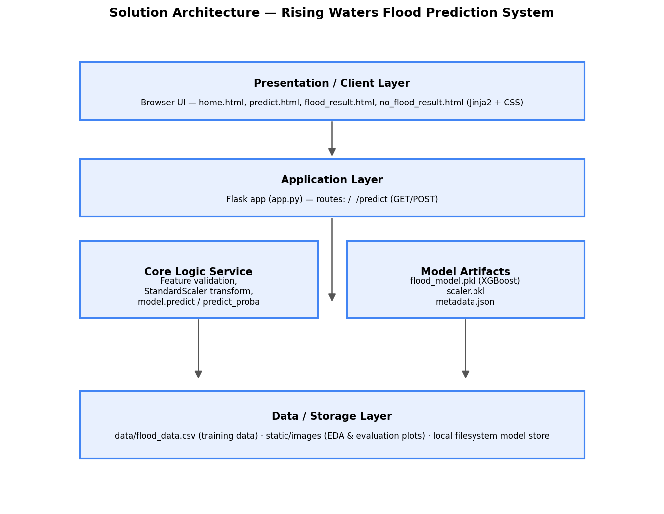

Component Description Table
Component Name | Description / Role in Architecture | Technologies Used
Presentation Layer | Renders the home, prediction form and result pages that residents/officials interact with | HTML5, Jinja2 templates, CSS
Application Layer | Flask app handling routing, form submission and orchestrating the prediction request | Python, Flask
Core Logic Service | Validates inputs, applies the saved StandardScaler, and runs the trained classifier | scikit-learn, XGBoost, pandas, numpy
Model Artifacts / Data Layer | Stores the trained model, scaler and metadata, plus the source training dataset and EDA images | joblib (.pkl), JSON, CSV, local filesystem

